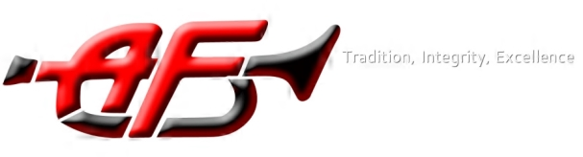

American Fork High School Band
Booster Board Meeting
May 8, 2018

Welcome – Bonnie Smith
Report on past month activity – Mr. Seamons
- Concert bands success—We listened to some comments from one of the judges. He was very complimentary of the band and Mr. Seamon’s musicality.
- Jazz concert—Guest artist was amazing and the kids played very well with him.
- Leadership—Student leaders have been chosen and are being trained.
- State solo/ensemble
Mr. Seasons talked about the high number of band students who received either academic or music scholarships. He will put more information on the web-site as he complies the data.
Upcoming Events:
- Jazz Dinner – Allison Dean—Please buy tickets!
Cake donations, other donations needed
- Tomorrow first MB rehearsal- Mr. Seamons—Make sure kids wear athlectic clothing and bring water, sunscreen, and hats.
- Sectional Uniform fittings/pick up (see dates below and on Charms)
- Sectionals are now in full swing, times are based on sections.
- Awards Concert- door monitors needed (3)
Finance update - Allison Dean—Jr. High students need to bring their money to the finance office at the High school.
Jr. High report- Bonnie Smith
- carpools

Calendar:
March 9-Marching Band rehearsal 3-6pm
March 10- Low Brass uniform fitting 2:15-3:30
May 11-12- Jazz Dinner
May 14- Saxes and Clarinet uniform fitting 1:15-2:30
May 15- High Brass and Flute uniform fitting 2:15-3:30
May 16- MB rehearsal 3-6pm
May 16- Advanced Jazz Band Senior Recognition night 7pm
May 17- Band Awards Concert 7pm High School auditorium
May 23- MB rehearsal 3-6pm
May 28- Memorial Day performance- AFJH auditorium
May 31-LAST DAY OF SCHOOL
June 9-Yard sale fundraiser- Fresh Market Parking lot 7am-12
June 18-21 Percussion Practice 7-9:30am
June 25-29 Fundamentals camp REQUIRED 7am-4pm
June 30- Lehi Roundup parade – call time tbd
July 2- MB rehearsal 7am-11am
July 2- Leadership training with Dr. Tim 12-4pm
July 2- Concert in the Park- call time tbd
July 4- Freedom Festival parade- Provo Call time tbd

