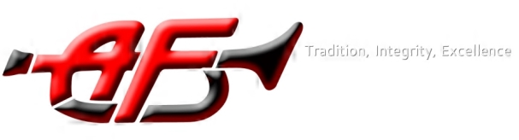
American Fork High School Band
Booster Board Meeting
October 3, 2017

Welcome- Stephanie

Mt.Timp Competition – Allison
- Sign-up on Charms to volunteer
- Volunteer meeting (Oct 17th)

Band Dads- Troy

Color Guard – Cynthia

St. George – Allison
- Chaperones for St. George – Allison (meeting on Oct 25th)
- Sign-up on Charms to volunteers at Red Rocks and BOA, St. George

Upcoming Events:
- Rehearsal mandatory on October 16th, Rehearsal cancelled on the 18th
- All American Band Ceremony, Oct 24th at 10:30-11:00am, band room.
- Parent meeting and vote for Nationals, Nov 15th

Report on past month-Nate
- Past Shows: Weber, Nebo, Bridgerland
- Clinician Camp

Finances/Band Fees- Jeremy
Jr. High – Mr. Major, Mr. Bateman

Calendar:
Oct 7 Wasatch (Herriman High School)
Oct 10 BYU
Oct 13 Pep band
Oct 14 Davis
Oct 19-23 Fall Break
Oct 24 All American Band Ceremony
Oct 28 Mt. Timp (at PGHS and AFHS)
Nov 2-4 St. George, Red Rocks and BOA
Nov 8 Awards Banquet 5pm
Nov 15 Band Bash 7pm (parent vote after)

