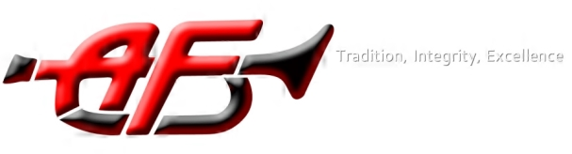

American Fork High School Band
Booster Board Meeting
March 12, 2019
Welcome – Bonnie Smith

Review: Mr. Seamons

Winter Guard update- Cynthia Brown—The new flooring came in and was able to be used last Saturday for the competition. Everyone loves it!

Band Dad needs- Dusty Miller—An email was sent out telling about the various need this weekend. Please come help if you’re able!

Cuttime: Allison Dean—The band is now using CutTime. We are experiencing a few growing pains; please be patient as the bugs are worked out.

Even past students are listed on CutTime. This allows us to inform students of alumni events.

Jr. High will move from Charms to CutTime at the end of the year. Those students attending 9th grade next year will eventually need to have two CutTime accounts—one for Jr. High events and one for Marching Band.

First Annual Band Banquet- April 12 Noah’s event center in South Jordan
Tickets $20 per person until March 15
$25 per person March 16-April 9
Tickets may be purchased at the finance office or through OneStop.

Marching Band 2019

Fee Schedule—The fee schedule may be found online with the contract.
Leadership—Student leadership is receiving training before school through the month of March.
Contracts—Due March 29, except for percussion which will be due after their try-outs.
Reveal—Everyone involved in Marching band this year is invited on Friday night to learn about the new show and watch a movie.
MB 101—This meeting is for all students and parents who are new to the marching band program. April 24, 7 p.m.
Step off Meeting—For all band parents—April 30, 7 p.m.
Fundraising—A fundraiser was started yesterday. We are selling first aid kits. This fundraiser ends March 27. The money raised will be used towards the marching band deposit. Please gather your money and turn it all in either in cash or credit card to the finance office with your sales sheet. No check are accepted at the school. Please contact Allison Dean if you have more questions.

Calendar events:
March 14: Jazz Band auditions
March 15: Marching Band show reveal/ Movie night
March 16: Winter Guard show at Westlake
March 16: PAS Juan Diego HS
March 22: Jazz State Festival
March 26: Pre-Festival concert 7:00
March 27: Region Band Festival Bingham HS
March 28: Marching Band Percussion auditions 3:00
March 29: Marching Band contract and deposit due
April 1-5: Spring Break
April 9: Drum Major auditions
April 9: Booster Meeting
April 10: Section Leader auditions
April 11: MB Percussion auditions 3:00
April 11: Fall color guard auditions 3:30
April 12: Band Banquet- Noah’s event center South Jordan

